Aecorsoft Data Integrator is a ELT/ETL tool which extracts SAP data and can load them to Azure Data Lake (ADLS) or other sinks. In our project landscape Aecorsoft extracts the data and loads in the ADLS and then from the ADLS, Agile Data Engine (ADE) and Data build Tool (dbt) transforms the data and loads into Snowflake. So as to build a End to End a monitoring solution I wanted to check the Aecorsoft’s daily log for any error and its corresponding error job and store it in the Azure Log Analytics Workspace for a monitoring dashboard solution.

In this part trying the parse the Aecorsoft daily logs using powershell script. There are separate error log but those are in binary format and cant be parsed.

Aecorsoft Log Console UI :

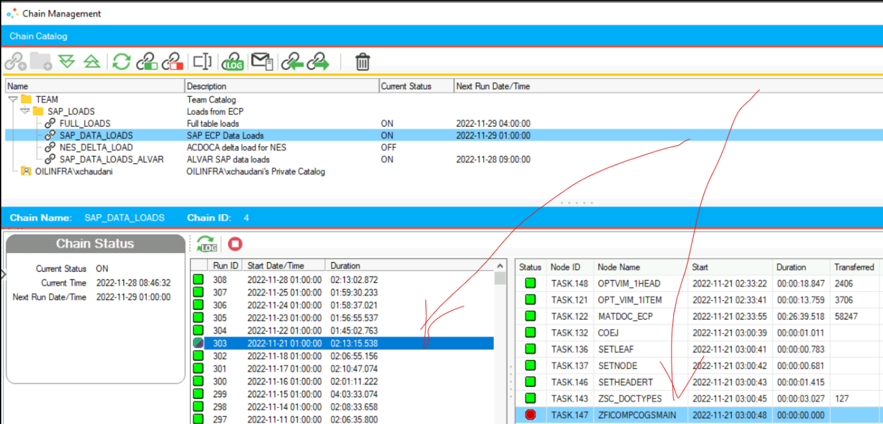

These logs are stored in the VM under C:\ProgramData\AecorsoftDataIntegrator\logs\

The script are executed by Windows scheduled task. The script is attached: 

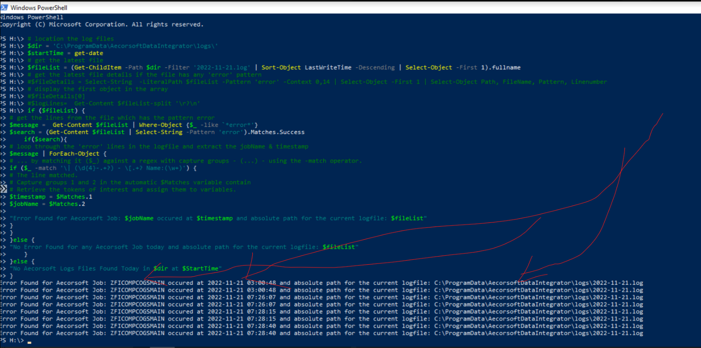

There were multiple runs for this job and shows the client the error for every instance.